Weston Parish Council Asset Register
at 13.11.25
Asset Name | Location | Status
Minutes and records | Herts County Council archive | Includes Village Hall deeds
Framed Map of Village | Village Hall
Village Green | Fore Street / Maiden Street | VG 088 Village Green, maintained by Weston Parish Council
Village Pond | Village Green | As above
Display Board | Village Green | Installed February 2015
Village Sign on pole | Village Green
Small Triangular Green | Damask Green Road / Hitchin Road junction, by Red Lion | Registered March 2013
Small Green | Damask Green Road/Park Drive | Common Land
Land outside Marlborough Close | Damask Green Road border | CL278, Common Land maintained by Weston Parish Council
Jackson’s Lane Car Park including tree | Outside Village Hall | Annual Maintenance due Sept. Covenants in place.
Forge End frontage, not including kerbs, but including trees |  | Calor Gas Storage tanks in place. Not owned by PC but grass is cut by PC.
Two lamp standards | On School Lane footpath nr Church
Chalk Pit | Weston Park Farms | Rented to Weston Park Farms, via Weston Settlement. £86pa invoice in March
Jackson’s Lane | Lane alongside car park | HD466571 Land Rgsty. Resurfaced 9/2014
Recreation Ground | Rear of Jackson’s Lane | Registered Charity 302501
Pavilion Building | Recreation Ground | Regular Electrical Check every 5 years. Next due March 2027.  NB Total Tennis Club facilities rented to Tennis Club. WPC pay water bill, electricity costs to Tennis Club
Changing rooms | Recreation Ground | Installed Sept 2011. Regular electrical check every 5 years. Next due March 2027
Storage container | Recreation Ground | Purchased August 2019
Pavilion Building Cess pit with overflow | Recreation Ground | Emptied as required.
Basket Ball Surface | Recreation Ground | Clean as required
2 Basket Ball Posts | Recreation Ground | Annual safety Inspection
Goal Posts | Recreation Ground
Tennis Court Surface and Play Surfaces | Recreation Ground | Annual Clean
Tennis Court fence | Recreation Ground
Play Area Towers | Recreation Ground | Annual safety Inspection
The Orbit | Recreation Ground | Annual safety Inspection
The Spinner | Recreation Ground | Annual safety Inspection
Junior Swing (Birds Nest seat) | Recreation Ground | Annual safety Inspection

Asset Name | Location | Status
Junior Swing (2 bay standard, 2 flats, 2 cradles) | Recreation Ground | Annual safety Inspection
Safety barrier x 4 | Recreation Ground | Annual safety Inspection
Trapeze walk | Recreation Ground | Annual safety Inspection
Log walk x 2 | Recreation Ground | Annual safety Inspection
Mini web | Recreation Ground | Annual safety Inspection
Log walk x 2 | Recreation Ground | Annual safety Inspection
Zig zag stepper | Recreation Ground | Annual safety Inspection
Log walk | Recreation Ground | Annual safety Inspection
Jungle walk | Recreation Ground | Annual safety Inspection
Safer grass x 51sq.mtrs  (includes fixings & underlay mesh) | Recreation Ground | Annual safety Inspection
Wetpour (installed) | Recreation Ground | Annual safety Inspection
Picnic benches x 2 | Recreation Ground | 1 purchased 3/19, 1 more 7/21
Swings | Snipe Play area | Annual safety Inspection
Area Log Walk | Snipe Play area | Annual safety Inspection
Giggleswick | Snipe Play area | Annual safety Inspection
Jolly Roger | Snipe Play area | Annual safety Inspection
Balance Weaver | Snipe Play area | Annual safety Inspection
Picnic benches x 2 | Snipe Play area
Bench 1 | Back of Village Green | Replacement bench installed 2021
Bench 2 | Back of Village Green | Replacement bench installed 2021
Bench 3 | Village Green, Under Chestnut Tree
Bench 4 | Recreation Ground play area
Bench 5, recycled plastic | Corner of Friars Road
Bench 6 | Malborourgh Close
Bench 7 | Entrance to Park Drive
Bench 8, recycled plastic | Post Office Row | Installed August 2011
Bench 9 | Village Green | Donated 2013. Maintenance & replacement responsibility of donor
Bench 10 | Fore Street | Installed 2016
17 Weston Walkabout Benches & 1 Picnic Table | See map | Installed 2021
Notice Board 1 | Post Office Row
Notice Board 2 | Damask Green Road
Notice Board 3 | Outside Village Hall
Notice Board 4 | Halls Green
Dog Bin 1 | Malborough Close | 270
Dog Bin 2, 3 & 4 | Recreation Ground | 268, 269, 313 (1Replaced Mar 2020)
Dog Bin 5 | Snipe Play Area | 272
Dog Bin 6 | Friars Road Garages | 271
Salt Bin 1 | Mill Lane | Adopted
Salt Bin 2 | Green End | Adopted
Salt Bin 3 | Church Lane | Adopted
Salt Bin 4 (not WPC) | Friends Green | Adopted

Asset Name | Location | Status
Salt bin 5 | Hitchin Road | Adopted
Salt Bin 6 | Friars Rd Footpath opp PO Row | Adopted
Salt Bin 7 | Woodlands Meade | Installed 2021. Not adopted
Litter Bin 1 | Snipe Play area | Installed December 2018
Litter Bin 2 | Nr Tennis Courts, Recreation Ground
Litter Bin 3 | Play Area, Recreation Ground
Litter Bin 4 | Halls Green
Litter Bin 5 | Church Car Park
Xmas Tree lights and transformer | Cllr Moody’s home, except during December | Purchased December 2018
Filing Cabinet | Darnalls Hall Office
Flower meadow display board | Recreation Ground | Installed March 2012
Horse Trough & pump | Maiden Street towards Church End | Ownership unknown
Trophy | Filing Cabinet
Rose Bowl | Held by Unsung Hero of the Year | Held by Sabine Nilsson 2025-6
Unknown Tommy Statue and wreath | Held by Alistair Schofield | Purchased 2022
Bunting | Held by Jacky Jones | Purchased 2023
Defibrillator 1 | Village Hall
Defibrillator 2 | The Rising Sun Pub
Defibrillator 3 | Primary School
Defibrillator 4 | Hearne Training, Town Farm
Defibrillator 5 | Cricketers, behind bar
Well cover | Village Green
Water pump | Village Green
Table tennis table | Village Hall

Weston Walkabout 2020 Bench Locations
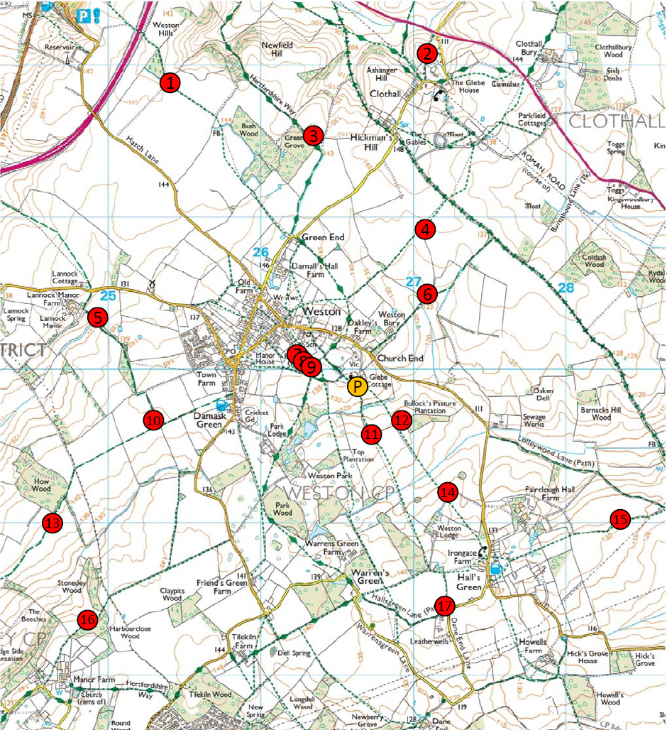

Trees

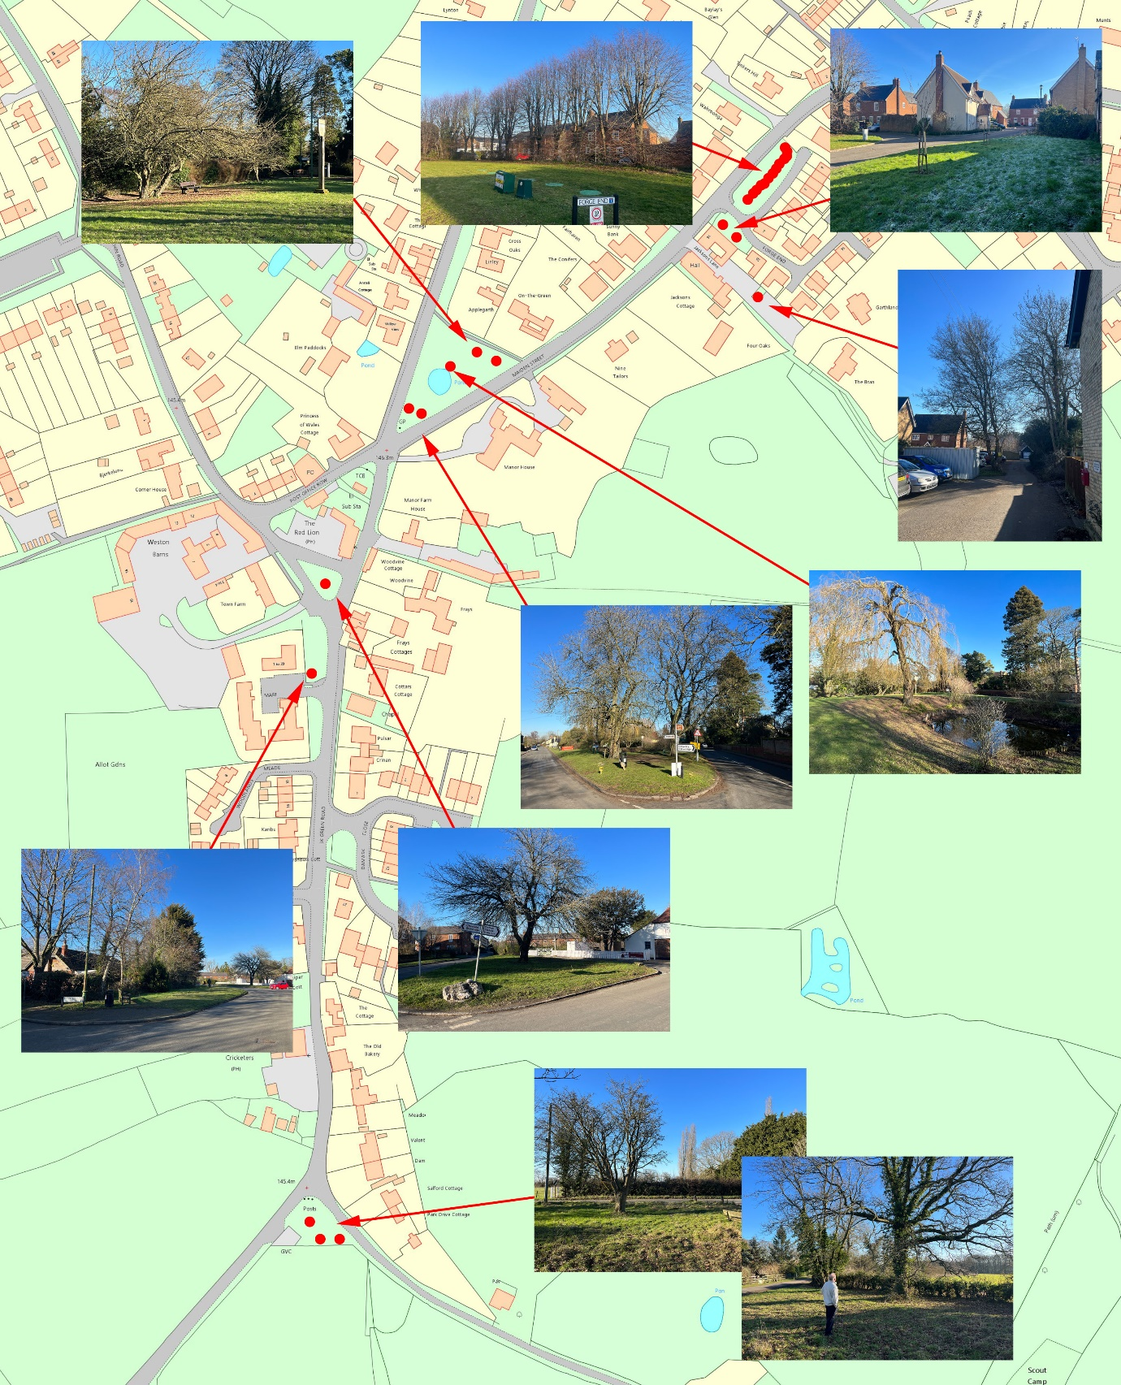

Description:

Forge End | 14 Lime trees. | Trees reduced Jan 2024
Forge End | 2 flowering cherry trees (Kanzan) | Planted by Cllr Tim Moody Apr 2021
Jackson’s Lane | Tree in middle of parking bays
Village Green | 2 Crab Apple trees
Village Green | Willow | Planted to commemorate VE Day, replacement tree planted by Terry Smith 10 years later.  Protected by Tree Preservation Order  Pollarded Dec 2022
Village Green | Large Chestnut Trees | Planted after the 1st World War by David Ginn’s grandfather.  Inspected 2015. Reviewed in March 2020.
Small Green next to Red Lion | Large Chestnut Tree | Original tree 2nd World War remembrance 1948, replaced c10 years later.  Inspection every 5 years, due March 2025.
Damask Green Road | Birch Tree | Believed to be self-set
Park Drive | Flowering cherry plus 2 other trees.

Large Trees in Recreation Ground | Recreation Ground | Maintained by Pryor Family under covenant

Document history
Tennis Club benches (two) removed as transferred to Tennis Club.  Football Dugout removed as demolished in 2020.  2 small litter bins removed as disposed of with dugout.  Salt bin on Friars Rd Footpath opposite Post Office Row added as omitted | Agreed by Council: 11/2/2021
2 picnic benches added in Rec  2 replacement benches installed on Village Green  2 flowering cherry trees planted in Forge End  17 Weston Walkabout benches and 1 picnic table added  New salt bin installed Woodlands Meade  Dog bin errors corrected and reference numbers added. | Agreed by Council: 10/2/2022  2022/02/018(c)
Section on trees added Feb 2023 following audit of tree assets.  Unknown Tommy Statue added | Agreed by Council: 9/11/23
Memorial notice board outside Forge End removed | Agreed by Council:  12/09/24
Litter Bin 5 added  Litter Bin 6 added  Wreath (Tommy Memorial) added  Defibrillator 1 added  Defibrillator 2 added | Agreed by Council:  12/12/24  2024/12/138
I picnic bench removed from Rec  Defibrillators 3-5 added. NB – not all were purchased by WPC  Litter bin removed from Jackson’s Lane as no longer there  Well cover and pump on village green added.  Table tennis table added | Agreed by Council:  13/11/25

